WLAN Chip Evaluation Test Plan

# Background

The goal of this document is to summarize basic tests required for evaluating a high-performance WLAN chip for Amazon products.

Tests are divided into sections, each section corresponding to one group of tests.

# Power consumption testing

Power consumption tests are divided into two groups: signaling and non-signaling. If time-limited, we should prioritize signaling tests over non-signaling ones.

## Non-signaling tests

For each specified Tx rate, the transmit power is pre-defined in table below.

Vendor to fill in the table:

|  |  |  |  |  |  |  |  |
| --- | --- | --- | --- | --- | --- | --- | --- |
| **TX** | | **Chip Port Power @Low /Mid /High channel (dBm)** | **Chip Port EVM  @Low /Mid /High Channel (dB)** | | | **EVM** | **Power consumption @3.3V** |
| **Conducted Non-Signaling** | | **Device1** | **Device2** | **Device3** | **IEEE** | **(mA)** |
| 2G | 11b 11Mbps | 19.5 | -26.6 | -26.9 | -26.9 | -10 | 243 |
| 11g 6Mbps | 18 | -24.2 | -24.1 | -23.9 | -5 | 190 |
| 11g 54Mbps | 17.5 | -31.3 | -31.3 | -32.2 | -18 | 171 |
| 11n MCS0 | 17.5 | -24.2 | -24.2 | -23.9 | -13 | 190 |
| 11n MCS7 | 17 | -30.9 | -30.7 | -32.1 | -28 | 170 |
| 5G | 11a 6Mbps | 17 |  |  |  |  |  |
| 11a 54Mbps | 16.5 |  |  |  | -25 |  |
| 11n MCS0 | 17.5 |  |  |  | -13 |  |
| 11n MCS7 | 16.5 |  |  |  | -28 |  |
| 11ac MCS8-20 | 16.5 |  |  |  | -30 |  |
| 11ac MCS9-40 | 14.5 |  |  |  | -32 |  |
| 11ac MCS9-80 | 14 |  |  |  | -32 |  |

Assume Ref board has 1dB RF FE loss

|  |  |  |  |  |  |
| --- | --- | --- | --- | --- | --- |
| **RX** | | **Chip Port Rx Sensitivity @Low/Mid/High channel (dBm)** | | |  |
| **Conducted Non-Signaling** | | **Device1** | **Device2** | **Device3** | **PER%** |
| 2G | 11b 11Mbps | -86.6 | -87.1 | -87.0 | <10 |
| 11g 6Mbps | -92.9 | -92.9 | -92.9 | <10 |
| 11g 54Mbps | -75.7 | -75.9 | -75.6 | <10 |
| 11n MCS0 | -92.3 | -92.6 | -92.4 | <10 |
| 11n MCS7 | -73.0 | -73.0 | -72.6 | <10 |
| 5G | 11a 6Mbps |  |  |  | <10 |
| 11a 54Mbps |  |  |  | <10 |
| 11n MCS0 |  |  |  | <10 |
| 11n MCS7 |  |  |  | <10 |
| 11ac MCS8-20 |  |  |  | <10 |
| 11ac MCS9-40 |  |  |  | <10 |
| 11ac MCS9-80 |  |  |  | <10 |

Assume Ref board has 1dB RF FE loss

## Non-signaling tests – BLE

Provide Rx and Tx data at nominal temperature (25C). Test should cover LE at least.

## Wi-Fi only signaling tests

RvR plot should have X-axis as RxP and Y-axis as Throughput (Mbps)

Where, RxP (dBm) = (AP power – Attenuation (total)) @ antenna port of evaluation board

**Setup details:**

* BLE radio off
* **Netgear R7000** AP
* conducted setup
* TCP tuning parameters 🡪 Vendors to provide parameters used
* iperf parameters 🡪 Server side: iperf –s –i1 –w8m
* Client side: iperf –c xxx._dut_ip_.xxx.xxx –w8m –l8k –t30

**Test #1: 2.4GHz HT20 RvR:**

* Rx listen with PS off
* TCP DL
* TCP UL
* Power Consumption

**Test #2: 5GHz HT20 RvR:**

* Rx listen with PS off
* TCP DL
* TCP UL
* Power Consumption

**Test #3: 5GHz VHT80 RvR:**

* Rx listen with PS off
* TCP DL
* TCP UL
* Power Consumption

**Example table:**

|  |  |  |  |  |  |  |  |  |  |  |  |
| --- | --- | --- | --- | --- | --- | --- | --- | --- | --- | --- | --- |
| Vendor device | Bus (SDIO/USB) | Wi-Fi Traffic | UL/DL | Conditions | 2G/5G | Channel | MSC | Attenuator(dB) –done | RSSI (dBm) –to test | Throughput (Mbps)- done | Power (mW) |
|  |  |  |  |  |  |  |  |  |  |  |  |
|  |  |  |  |  |  |  |  |  |  |  |  |
|  |  |  |  |  |  |  |  |  |  |  |  |

**Example plot:**

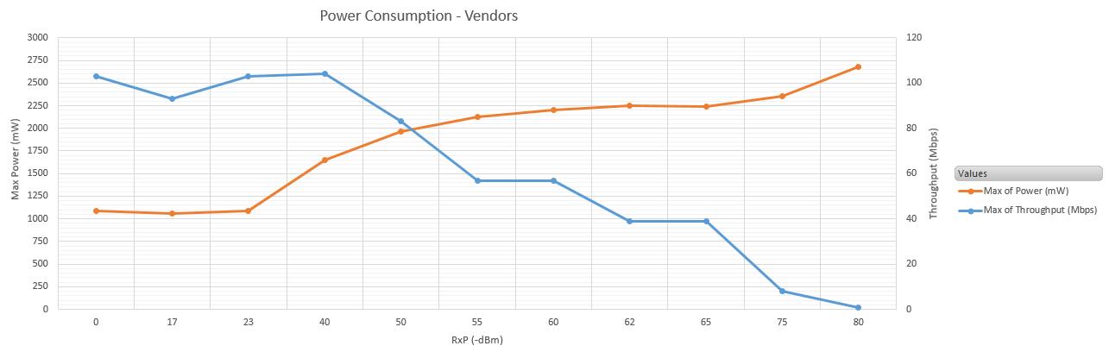

Figure 1

# Coexistence testing

Coexistence tests in this section are specifically designed for a three-antenna architecture (2x2 Wi-Fi and a separate Bluetooth antenna), to test the full duplex and hybrid coex schemes. Explanation of coex schemes is summarized in a table below. Setup up input power to 3.3V only

|  |  |  |  |
| --- | --- | --- | --- |
| Coex method | Per-packet RF adjustments (Tx power, Rx gain) | Per-packet scheduling (stop Wi-Fi or BT based on priority) | Comments |
| TDD (non-overlapping Wi-Fi and Bluetooth) | No | Yes | Wi-Fi and Bluetooth do not overlap in time; Wi-Fi traffic scheduled around Bluetooth traffic. |
| Full-duplex (Wi-Fi and Bluetooth operate in parallel) | Yes | No | Wi-Fi and Bluetooth operate in parallel. RF adjustments applied when needed to reduce impact from Wi-Fi to BT and vice-versa. |
| Hybrid (parallel operation except for certain modes when non-overlapping is forced) | Yes | Yes | Allow parallel operation except for the modes when RF protection is not enough and instead the chip enforces time-division duplex. |

**Conducted Block Diagram:**

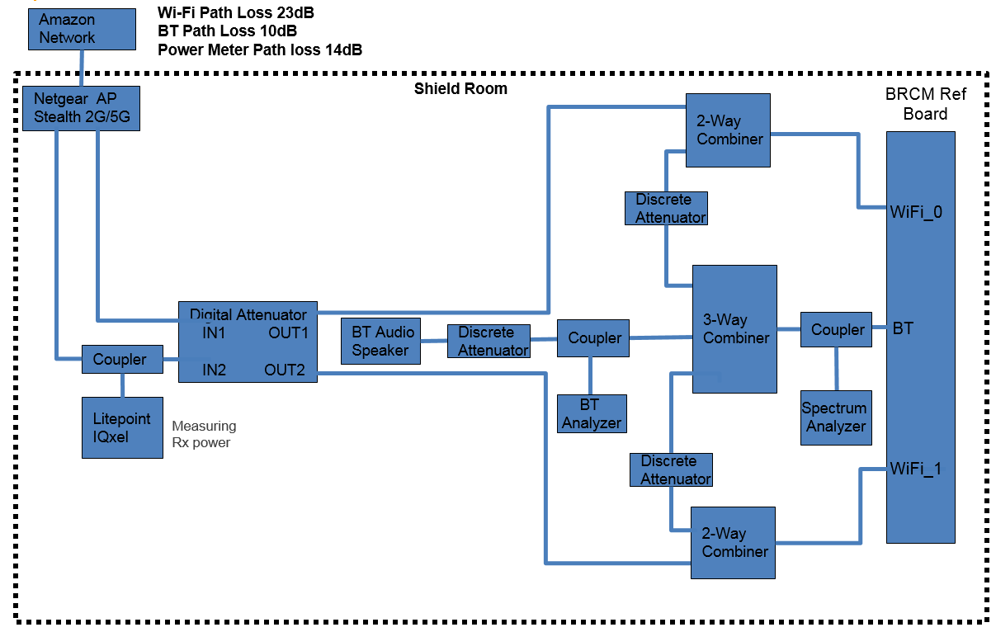

Figure 2

The goal is to repeat the following test suites across all antenna isolation values.

* Conducted test should be performed in steps of 5dB steps, when throughput starts to throttle then attenuation should be set in steps of 1dB.
* Antenna isolation: 15dB

**Test suite #1: Wi-Fi + BLE scan**

1. Wi-Fi TCP DL/UL RvR, no BT
2. BLE scan should be enabled continuously, measure BLE scan on a spectrum analyzer
3. Wi-Fi TCP DL/UL RvR with BLE enabled

**Example Table:**

|  |  |  |  |  |  |  |  |  |  |  |  |
| --- | --- | --- | --- | --- | --- | --- | --- | --- | --- | --- | --- |
| **AP Power** | **Path Loss** | **Attenuation** | **RXP** | **RSSI** | **MCS** | **Throughput[Mbps]** | **SNR** | **Channel/Frequency** | **UL/DL** | **Device** | **Ant Isolation** |
|  |  |  |  |  |  |  |  |  |  |  |  |
|  |  |  |  |  |  |  |  |  |  |  |  |

# Interference Mitigation testing

Below mentioned test will help to evaluate chip performance in an environment with external interference. In order to mimic real world scenario, we have defined three test cases as explained in section below

**Brief Explanation:**

**Setup:**

1. **Block Diagram:**

Ensure setup loss are correctly calibrated and taken into account before recording any readings

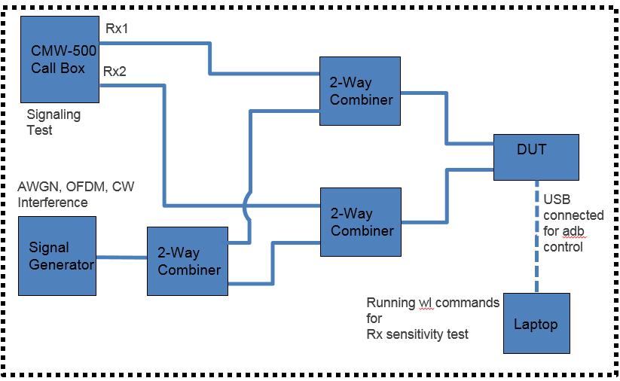

AP /

Figure 3

1. **Steps:**
2. Make connections as shown in the setup block diagram
3. Capture baseline readings with all noise source turned off
4. Measure Wi-Fi Rx sensitivity in presence of different noise sources defined in tests below

Select data rate (11a/g) 6Mbps

NOTE: For below mentioned tests (1, 2 and 3) please run either Rx sensitivity (preferred) or Throughput test

**Test#1**

**Rx sensitivity immunity to AWGN noise**

1. Enable AWGN noise source for 2437 (CH6)/5200 (CH40) MHz for VHT20
2. Select AWGN noise level start point 5dB lower than the measured baseline sensitivity (i.e. w/o noise source). Add path loss from equipment to DUT (ensure calculations are based on 20MHz) and plot AWGN noise on X-axis and Rx sensitivity on Y-axis
3. Sweep AWGN noise in an increment of at most 5dB steps and measure Wi-Fi sensitivity at CH-6/40 respectively
4. Example result:

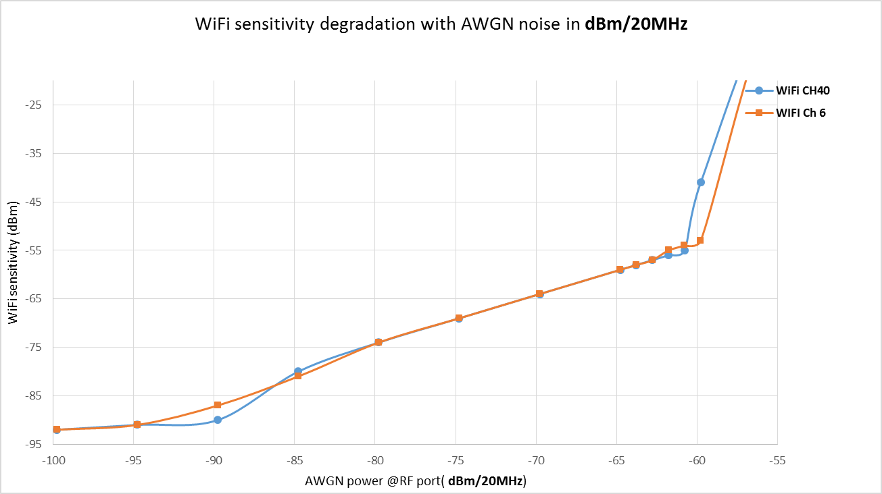

Figure 4

**Test#2**

**Rx sensitivity immunity to CW jammer**

1. Set CW generator frequency to 2440/5205MHz (In-band Jammer @ CH 6/40)
2. Add path loss from equipment to DUT, plot CW noise power on X-axis and Rx sensitivity on Y-axis
3. Sweep CW power in steps of at most 5dB
4. Example result:

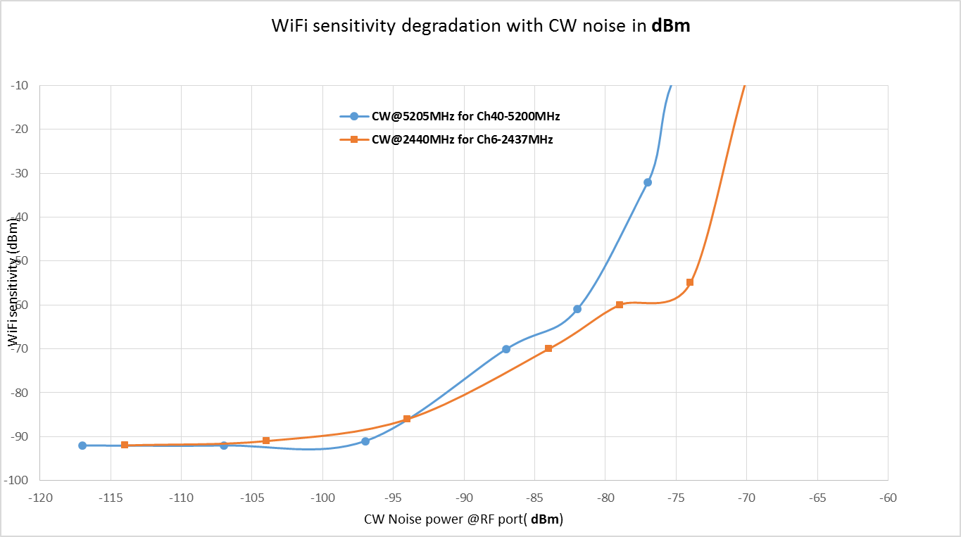

Figure 5

**Test#3**

**Rx sensitivity immunity to Wi-Fi (**adjacent channel rejection**)**

1. Set equipment to generate OFDM packets at channel 5180MHz (CH 36)/ 5220MHz (CH 44) one at a time. Measure sensitivity at 5200MHz (CH40)
2. Select noise level start point 5dB lower than the measured baseline sensitivity (i.e. w/o noise source).
3. Sweep OFDM adjacent channel power in steps of at most 5dB.
4. Add path loss from equipment to DUT (ensure calculations are based on 20MHz) and plot OFDM noise on X-axis and Rx sensitivity on Y-axis.
5. Repeat step 1 to 3 for 2G. Select ACI channels to be 2412MHz (CH1), then 2462MHz (CH11) and finally 2432MHz (CH 5). Measure sensitivity at 2437MHz (CH6).
6. Example result:

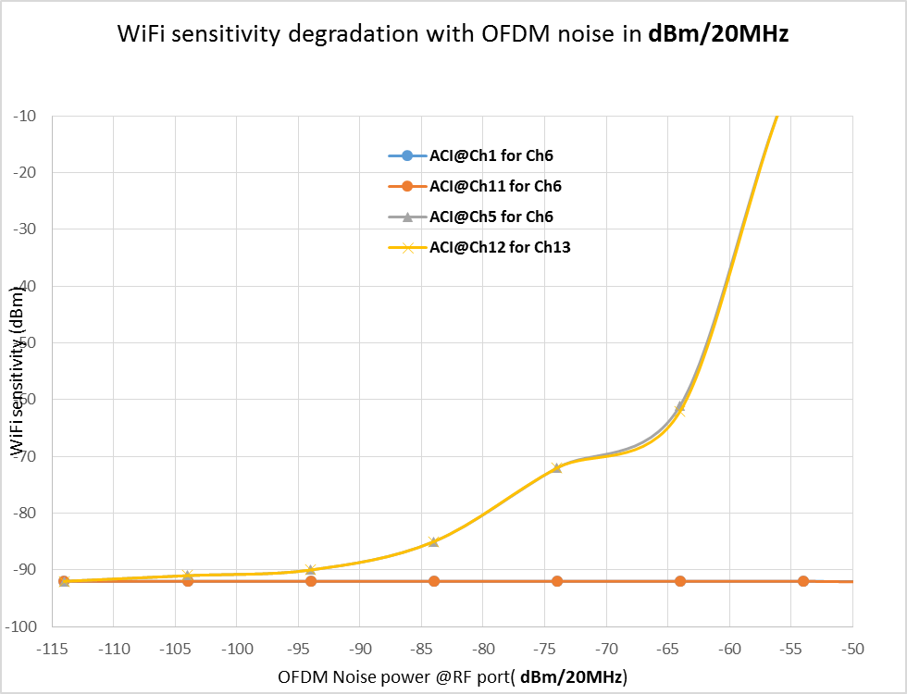

Figure 6

**Test#4**

**Rx sensitivity immunity to Wi-Fi (**Co-channel rejection**)**

1. Set equipment to generate OFDM packets at 2437MHz (CH 6)/ 5200MHz (CH 40) one at a time with 100% duty cycle and power set to -35dBm and -60dBm for 20MHz
2. Select noise level start point 5dB lower than the measured baseline sensitivity (i.e. w/o noise source).
3. Sweep OFDM adjacent channel power in steps of at most 5dB.
4. Add path loss from equipment to DUT (ensure calculations are based on 20MHz) and plot OFDM noise on X-axis and Rx sensitivity on Y-axis.

**Test#5**

**Throughput immunity AWGN noise**

1. Enable AWGN noise source for 2437 (CH6)/5200 (CH40) MHz for VHT20
2. Power level for AWGN should be set to -75dBm/20Mhz and -85dBm/20MHz. Add path loss from equipment to DUT (ensure calculations are based on 20MHz)
3. Perform throughput test with AP connected to DUT in presence of AWGN noise, plot RxP (dBm) on X-axis and throughput(Mbps) on Y-axis

**Test#6**

**Throughput immunity to CW jammer**

1. Set CW generator frequency to 2440/5295MHz (In-band Jammer @ CH 6/40) with power set to -70/20MHz then repeat for -80dBm/20MHz.
2. Add path loss from equipment to DUT, plot RxP (dBm) on X-axis and throughput(Mbps) on Y-axis

**Test#7**

**Throughput immunity to Wi-Fi (**adjacent channel rejection**)**

1. Set equipment to generate OFDM packets at channel 2412MHz (CH1), then 2462MHz (CH11) and finally 2435MHz (CH5) one at a time with 100% duty cycle and power set to -40dBm and -60dBm for 20MHz.
2. Perform throughput test with AP connected to DUT at CH6.
3. Repeat step 1 to 2 for 5G. Select ACI channels to be 5180MHz (CH 36)/ 5220MHz (CH 44) one at a time.
4. ED threshold should be set to -62dBm.

Note: For this test CMW should be replaced with an AP.

**Test#8**

**Throughput immunity to Wi-Fi (**Co-channel rejection**)**

1. Set equipment to generate OFDM packets (interference) at channel 2437MHz (CH 6)/ 5200MHz (CH 40) one at a time with 50% duty cycle and power set to -50dBm and -80dBm for 20MHz.
2. Perform throughput test with AP connected to DUT at CH6/40 respectively.

Note: For this test CMW should be replaced with an AP.

|  |  |  |  |  |  |
| --- | --- | --- | --- | --- | --- |
| **Sr No** | **Measure**  **Rx Sensitivity** | **Aggressor Type**  **Noise Source** | **Frequency offset from**  **2437MHz / 5200MHz** | **Priority** | **Noise power** |
| 1 | CH6 | WLAN | CH5 | P0 | -30dBm -50dBm -75dBm |
| CH8 | P0 |
| CH3 | P0 |
| CH10 | P0 |
| CH40 | CH36 | P0 |
| 2 | CH6 /CH40 | Modulated Sig >2MHz  (non-Wi-Fi packet  BT , ZB, LTE) | 5MHz | P0 | -30dBm -50dBm -75dBm |
| 10MHz | P0 |
| 15MHz | P0 |
| 20MHz | P0 |
| 3 | CH6 /CH40 | HDMI | - | P1 | TBD |
| 4 | CH6 /CH40 | CW | - | P1 | TBD |
| 5 | CH6 /CH40 | AWGN | - | P0 | TBD |

# Bluetooth performance

Setup details:

* Wi-Fi radio OFF
* Put the device in shield box
* Perform radiated test
* Use sniffer capture tool

**Test Suite #1: Inquiry Performance (protocol)**

1. BLE only (at least 5 BLE devices)

Data from the tests:

1. BLE sniffer air trace
2. Plot of channel (frequency vs time) plotting the inquiry packets.
3. Time to inquiry response

**Test Suite #2: Page Scan Performance**

1. Time to reconnect with BLE (Logitech BLE
2. keyboard)

Data from the tests:

1. Connection time (5 iterations)
2. BLE sniffer air trace

# Compliance Tests

Share compliance reports, we are expecting at least results for the following tests mentioned below

|  |  |  |  |
| --- | --- | --- | --- |
| Certification | Standard | Technology | Description |
| FCC | FCC Part 15 Sub part C §15.247 (Part E 15.407 for 5G) | WLAN/Bluetooth | Conducted Band Edge and Spurious Emissions |
| CE | ETSI EN 300 328 V2.1.1 TC 5.4.6 | WLAN/Bluetooth | Adaptivity (Channel access mechanism) |
| CE | ETSI EN 300 328 V2.1.1 TC 5.4.8 | WLAN/Bluetooth | Transmitter unwanted emissions in the out-of-band domain |
| CE | ETSI EN 300 328 V2.1.1 TC 5.4.9 | WLAN/Bluetooth | Transmitter unwanted emissions in the spurious domain |
| CE | ETSI EN 300 328 V2.1.1 TC 5.4.10 | WLAN/Bluetooth | Receiver spurious emissions |
| CE | ETSI EN 300 328 V2.1.1 TC 5.4.11 | WLAN/Bluetooth | Receiver Blocking |
| FCC | FCC Part 15 Sub part E §15.407 | WLAN | 5GHz Conducted Band Edge and Spurious Emissions |
| CE | ETSI EN 300 893 | WLAN | 5GHz |